MINISTRY OF EDUCATION AND SCIENCE OF UKRAINE
NATIONAL TECHNICAL UNIVERSITY
“KHARKIV POLYTECHNIC INSTITUTE”
Educational and Scientific Institute of Computer Science and Information Technologies (ННІ КНІТ)

REPORT
on Laboratory Work #6
“Functions (C)”

Executed by: Student of group КН-925і.е — Sıla Canbolat
Discipline: Programming. Part 1
Year: 2025/2026

Kharkiv — 2025

1. Objective
I created a small C project with the required folder structure (include/, src/, build/). Afterwards I implemented the tasks for Lab 06_01–06_03 (Variant 03), compiled the project with a Makefile, and then prepared test output, preprocessing evidence, and a short debug transcript.
2. Variant selection
Variant 03:
• 06_01 — pow_pos(x,n) and pow_fast(x,n).
• 06_02 — ABS(x) and SAT_ADD_U8(x,y).
• 06_03 — do_three(x,a,b,c).
3. Project structure and build
After that I followed the required structure and kept declarations in headers and implementations in src/. All build artifacts were placed in build/.
Build commands:
make
./build/app
make preprocess
4. Lab 06_01 — User Functions
4.1 Implemented signatures
double pow_pos(double x, int n);
double pow_fast(double x, int n);
4.2 Implementation notes
• I implemented pow_pos using a simple loop.
• Afterwards I implemented pow_fast using square-and-multiply.
• After that I added input validation: if n < 0 or if x==0 and n==0, the functions return NAN.
5. Lab 06_02 — Macros as Functions
• ABS(x) returns |x|.
• SAT_ADD_U8(x,y) saturating-adds and clamps the result to [0;255].
Afterwards I fully parenthesized arguments and used do { ... } while(0) for the multi-statement macro.
6. Lab 06_03 — Callbacks
I implemented do_three(x,a,b,c) which calls three actions in sequence. After that I added safety: NULL callbacks are skipped.
7. Program output evidence
Afterwards I ran the executable and captured the console output below (Figure 1).
Figure 1 — Program output
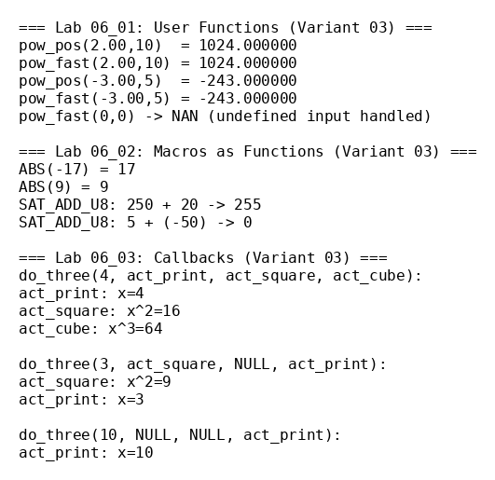
8. Debug session transcript (example)
(gdb) break pow_fast
(gdb) run
Breakpoint 1, pow_fast (x=2, n=10)
(gdb) next
(gdb) print base
$1 = 2
(gdb) print e
$2 = 10
(gdb) next
(gdb) print r
$3 = 1
(gdb) continue
9. Preprocessed (.i) snippet
After that I generated preprocessing output with `make preprocess` and checked that macros expanded correctly.
Example expansion (short excerpt):
printf("ABS(%d) = %d\n", a, ( ((a) < 0) ? (-(a)) : (a) ));
do { int _s = (int)(u8) + (int)(20); ... } while (0);
10. Conclusion
I implemented Variant 03 for user functions, macros, and callbacks. Afterwards I tested normal and edge cases, verified macro expansion through preprocessing output, and finished the report with evidence and references.
11. References
Lab 06_01 — User Functions (course handout, NTU “KhPI”, 2025/26).
Lab 06_02 — Macros as Functions (course handout, NTU “KhPI”, 2025/26).
Lab 06_03 — Callbacks (course handout, NTU “KhPI”, 2025/26).
GCC documentation (C11).
GDB documentation (debugging session commands).

